The Chambers of Commerce, Industry, Agriculture and Handcrafts are the most effective point of contact between Italian institutions and companies, especially small and medium-sized ones; all the companies established in the national territory are registered in the Business Register (kept by the Chamber of Commerce).

The Chambers of Commerce, as a public entity, have been assisting Italian companies since 2017 with a free, electronic invoicing service that meets all the obligations in force in Italy, the digital platform is designed for simple use (directly) by the entrepreneur.

For the above reasons, the EeISI project has expressly provided that the dissemination action aimed at small and medium-sized enterprises should take place (at least) in 15 Chambers of Commerce distributed throughout the national territory.

The design of the interventions has concerned first of all the contents to be illustrated, starting specifically from the practical interest and usefulness of the entrepreneur. For Italian companies all already get used to electronic invoicing, it has been appropriated to explain the differences between domestic and EU electronic invoice and to define the reference scenario, all focused on the supply of goods and services to public administrations. All the dissemination events have been completed by a practical demonstration of the electronic invoicing platform made available free of charge by the Chambers of Commerce to entrepreneurs.

Since April of the current year, this digital platform allows to the entrepreneur to fill out an invoice like in use for domestic duties and to send that to a public administration of the EU in the format required by the European standard. The delivery can be done through the Peppol network if the recipient public administration joins this network.

To select the Chambers of Commerce to involve in organizing and implementation of the dissemination events, Unioncamere sent a call of interest to all Chambers of Commerce with the EeISI project's explanation and the invitation to apply for. The list of eligible Chambers of Commerce has been established according to the "who comes first is served first" principle, under the condition to realize an homogeneous diffusion of the events throughout the national territory. Finally, the following were selected: five Chamber of commerce in the southern regions, 4 Chambers of commerce in the central regions and 6 in northern Italy.

Guidelines for organizing events according to a program defined by Unioncamere were provided to the 16 selected chambers of commerce, moreover direct assistance was provided at all stages of the organization, including the participation of a Unioncamere speaker (Dr Mario Altavilla) to present the EeISI project on the day of the event. At the end of the EeISI project, a contribution equal to 80% of the expenses incurred, was paid to the 16 Chambers of Commerce that carried out the events, a maximum limit of € 4,000.00 was set for the contribution.

The 16 meetings held at the Chambers of Commerce took place between June 20 and December 11, the informative impact on small and medium-sized enterprises was significant; an average of 50 entrepreneurs attended each of the events, with a maximum of almost 100 entrepreneurs present in Treviso, at the Treviso-Belluno Chamber of Commerce, on 23 October. The information coverage created with the dissemination events has been however much more extensive, in fact all the Chambers of Commerce have:

* carried out an information campaign on the event, by posting news on own institutional website, publishing the poster and sending a specific communication via e-mail to a selection of over 143,000 companies,
* operated through social media and the local press,
* informed the representative associations of entrepreneurs operating in the area.

The following table summarizes the main data relating to all the events:

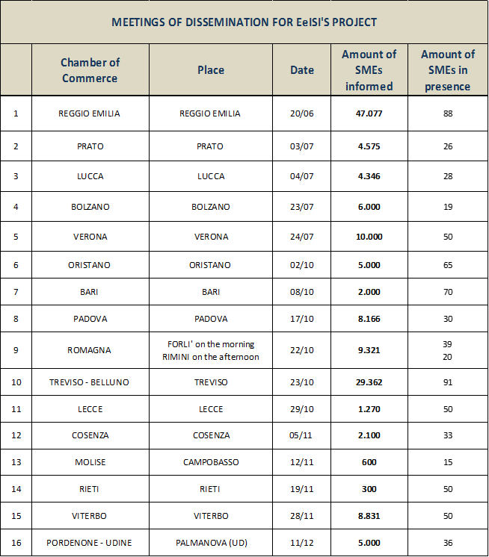

The entrepreneurs that participated in the meetings showed some disorientation with the differences between national and european scenario: widespread obligation vs. voluntary use by companies; different protocol and electronic format between the invoices they issue in Italy and those they will issue to the EU.

In any case, they have shown satisfaction and interest in the free public service that the Chambers of Commerce offer them thanks to the outputs developed by the project, and they have appreciated that much of the complexity has been solved in a practical way by digital technology.

In order to complete the information provided, the file "dissemination.zip" is attached. It contains 16 folders entitled with the name of the city where the dissemination event took place, each of the folders contains (only in Italian):

* the final report on the event,
* pictures taken in place,
* poster of the event and text of the invitation e-mail,
* any press releases and other material extracted from the web and/or social media.